Mini Project Report – Applied System Development

./



Life Cycle and Software Testing

Electric Vehicle Charging Station



### Document History

|  |  |  |  |  |  |
| --- | --- | --- | --- | --- | --- |
| **Ver. Rel.**  **No.** | **Release Date** | **Prepared. By** | **Reviewed By** | **To be approved by** | **Remarks/Revision Details** |
| 1 | 24/08/2021 | 99005798 | 99005848 | Patrick Andrews |  |
| 2 | 24/08/2021 | 99005787 | 99005853 | Patrick Andrews |  |
| 3 | 24/08/2021 | 99005799 | 99005766 | Patrick Andrews |  |
| 4 | 24/08/2021 | 99005767 | 99005830 | Patrick Andrews |  |
| 5 | 24/08/2021 | 99005798 | 99005835 | Patrick Andrews |  |



Contents

Document History 2

Introduction 4

Product Built: Electric Vehicle Charging Station 5

SWOT Analysis 5

4W's and 1'H 6

Who 6

What 6

When 6

Where 6

How 6

Requirements 7

Research 7

Features 8

Objectives 8

Cost and Features 8

Defining the System 8

How to Run 9

Detailed Requirements 10

High Level Requirements 10

Low Level Requirements 10

Design 12

High level Requirements 13

Low level Requirements Diagram 15

Test Plan 17

High Level Test Plan 17

Low Level Test Plan 18

Program Outputs 19

Contributions 24



# Introduction

E-mobility is emerging as one of the fastest modes of transportation as it serves zero emission without the use of any fossil fuel. The cleaner and greener mobility will also serve in reducing the CO2 emission content in the atmosphere and help to reduce global warming. However, to make thee-mobility grow faster the production and management of electricity is of the main objective. The main demand of the electric vehicle is the charging methods and its infrastructure.

As a daily routine, most people will like to have their vehicle charged at the beginning of the day. The preferable location of the charging stations is most likely either near to their own residence or at their work places. Apart from it charging stations at the common public places will be popular. Also, the time of the charging of the vehicles is also an important criterion. Most of the people won’t like to stop for 2-3 hours for charging of the vehicles. Thus, the methods of the charging stations will need to deploy in an organised manner such that people could charge at minimum possible time period.

In the intercity conditions, the demand of the charging will remain obviously very high most of the times. Thus, to deliver optimum power to all the stations at high rate is a challenging task. In the outskirts of the city, the demand might not remain high as compared to the intercity, but installation of the public charging interface at such locations must be deployed with utmost planning. The main responsibility is to create Charging Structure Infrastructure.

An EV charging station, also called an EV charger or ELECTRIC VEHICLE SUPPLY EQUIPTMENT (EVSE), is a piece of equipment that supplies electric power for charging plug-in electric vehicles (including hybrids, neighbourhood electric vehicles, trucks, buses and others). The EV charging station is written in C language with proper testing cases and make file.

# Product Built: Electric Vehicle Charging Station



# SWOT Analysis

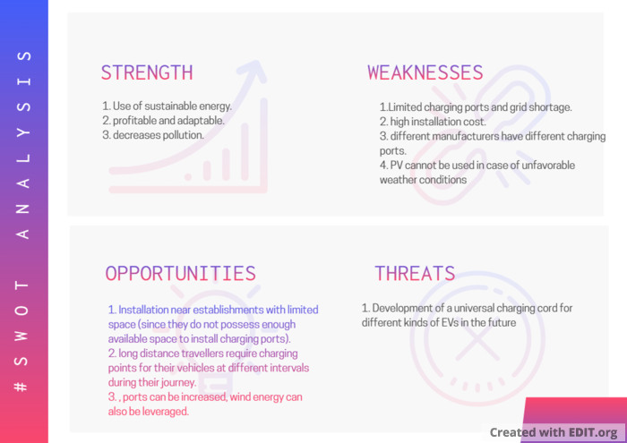

# 4W's and 1'H

### Who

### What

### When

### Where

### How

* Anyone who wants to charge their EVs(Electrical Vehicles).
* Sustainable Hybrid EV Charging System
* Can be used in all seasons, in any weather condition.

* Public spaces, Petrol Pumps, National and State Highways.
* Creating a profitable, sustainable energy solution for charging EVs.





# Requirements

## Research

The government has set the target of achieving 100% Electric vehicles by 2030. Manufacturing and putting the electric cars on road are the visions to make India pollution free along with saving billions of dollars in fuel cost and creating new job opportunities and to meet this goal government has to create Charging Structure Infrastructure.

Automotive Mission Plan (AMP) has been finalised jointly by Government of India and Indian Automotive Industry. The vision of AMP 2026 is, by 2026, the Indian Automotive industry will be among the top three of the worlds in engineering, manufacture and export of vehicles and components, and will encompass safe, efficient and environment friendly conditions for affordable mobility of people and transportation of goods in India comparable with global standards growing in value to over 12% of India’s GDP and generating an additional 65 million jobs.

[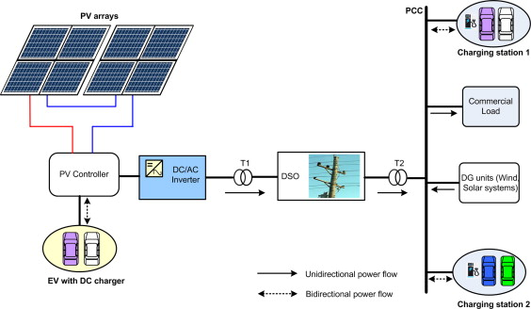](https://github.com/amulyasingaraju/SDLC_13_GoGreen/blob/main/1_Requirements/1-s2.0-S1364032114001920-gr8.jpg)

Electric car uses alternate fuel electricity instead of petrol or diesel. There is a growing acceptance for hybrid and electric cars in the country and more and more manufacturers are entering this niche segment with an express objective of lowering the fuel import bill and running cost of vehicles. Conversion of vehicles to electric vehicles has a potential to save fossil fuels worth about $100 bn annually, which in turn would save the country precious foreign exchange, prevent the dependence on imported petroleum products and reduce the pollution in cities by 80-90%.

By the year 2030, the Indian Government wants India to be 100%, electric vehicle nation.

India spent Rs 4.7 Lakh Crores in 2016-17 in importing crude oil. Electric Vehicles will help lower the bill.

Every car sold in India from 2030 will be electric, under new government plans.

India aims to become a 100% electric vehicle nation by 2030. The National Electric Mobility Mission Plan (NEMMP) targets seven million electric and hybrid vehicles by 2020.

One of the most important considerations with this project was to ensure EV charging station diversity in location, organization and facility type. With a growing number of local and regional carbon-reduction policies, EV charging stations may be able to benefit from the value of carbon emissions offset by their stations.

## Features

* Helps in charging multiple EVs at a time.
* EV Charging Station with 5 modular charging ports – 3 Scooters and 2 Cars at a time.
* Each charging port provides power output as needed by the vehicle.
* System is adaptable to all seasons.
* Charges EV considering the required safety protocols and monitors overcharging of EV as well.

## Objectives

* Clean Air Commitment.
* Lower cost of driving
* EVs pave the way to other forms of clean transportation.
* Electric vehicles support environmental justice.
* EV charging increases property value.



## Cost and Features

* The advantage of this project the quickness in which the program works and no need to perform heavy calculation which will be taken care by the program
* A lot of time and money can be saved in this project as the result leads to quick installation and accurate results.

## Defining the System

The system will be getting some essential parameters from the user and it will compute the values and with which it will be able to choose or design the product.

## How to Run

# For Building the main application

make all

# For Running the main application

make run

# For Building the test file

make test

# For Building the target file

make target



# Detailed Requirements

## High Level Requirements

| **ID** | **Description** | **Status** |
| --- | --- | --- |
| HR_01 | Getting Input from PV | Implemented |
| HR_02 | Check for power consumption of the EV – if more is required, grid can be used. | Implemented |
| HR_03 | Cost calculation for charging EV | Implemented |
| HR_04 | Profit calculation for plant owner | Implemented |
| HR_05 | Net metering (feedback to grid) | Implemented |
| HR_06 | Take power from both solar and grid | Implemented |

# Low Level Requirements

| **ID** | **Description** | **Status** |
| --- | --- | --- |
| LR_01 | Calculation of PV Power | Implemented |
| LR_02 | Calculation of load demand | Implemented |
| LR_03 | Checking power condition (check for mode of operation – islanded/grid) | Implemented |
| LR_04 | Grid - PV Power < Load; Take power from grid & Net Metering and Islanded - PV Power >= Load; Directly power the station & send surplus to grid | Implemented |
| LR_05 | Calculation of EV Power Consumption | Implemented |
| LR_06 | Calculation of power used in net metering | Implemented |
| LR_07 | For charging port 3 scooters, 2 cars (3x3 + 2x50 = 109) kWh Max power when all ports are being used. Check whether power is within constraints for each vehicle (for vehicle safety) Scooter – 3kWh, Car – 50kWh | Implemented |
| LR_08 | What is maximum amount of power being produced by PV and how many vehicles can be charged in a day? (Assuming PV Max Power = 120kWh) | Implemented |





# Design



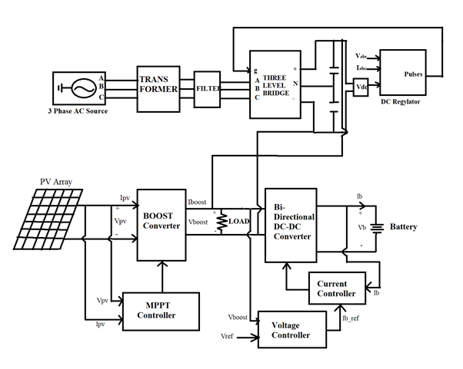

## High level Requirements

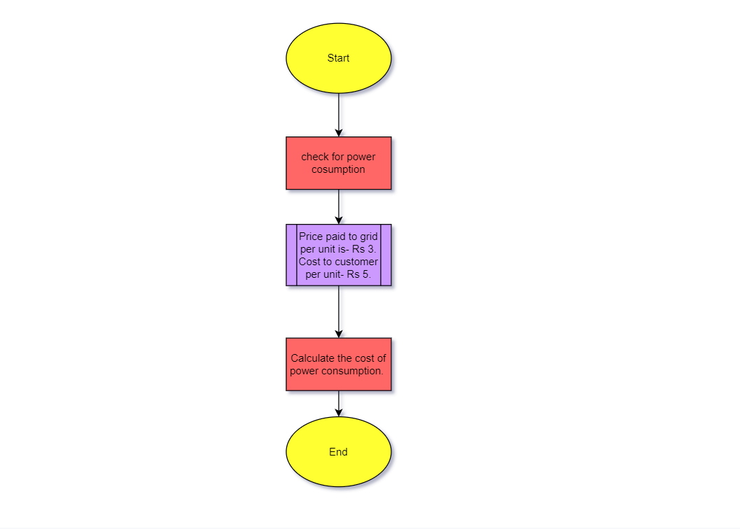

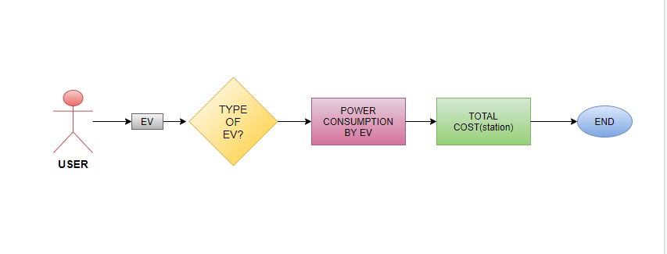

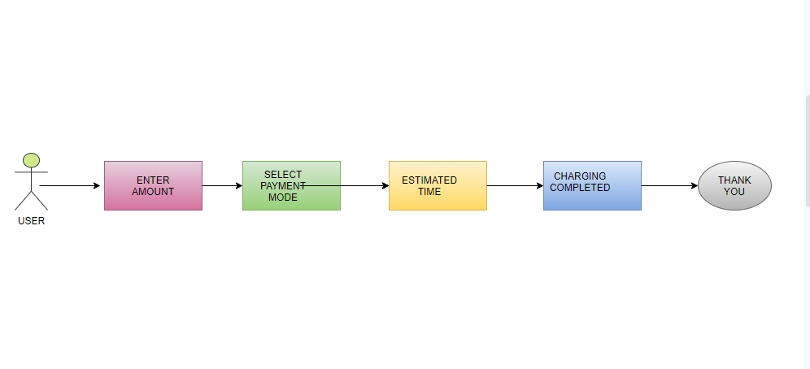

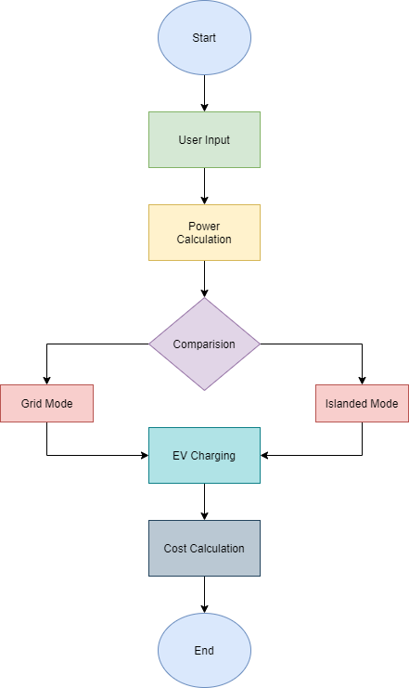

## Low level Requirements Diagram

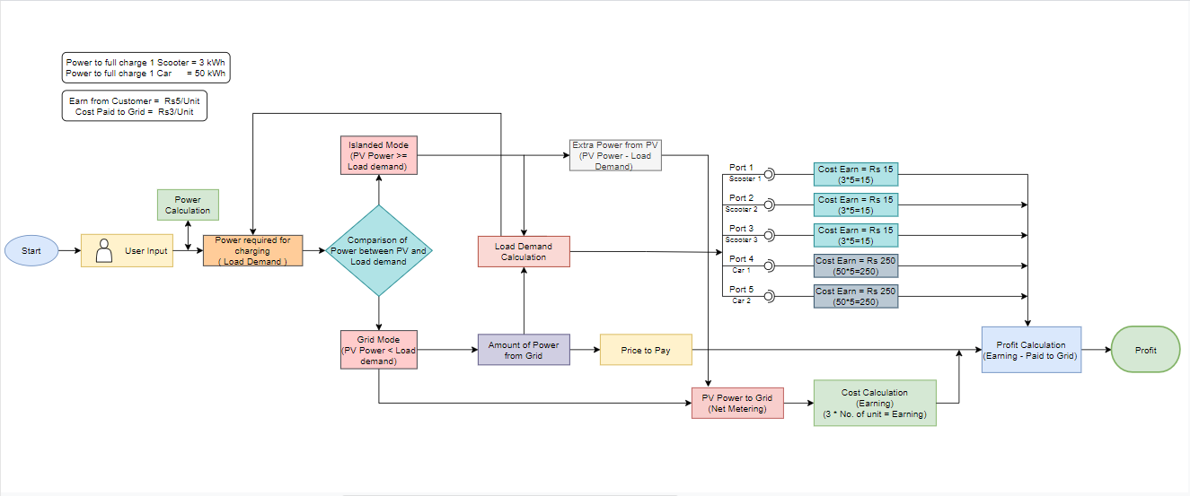

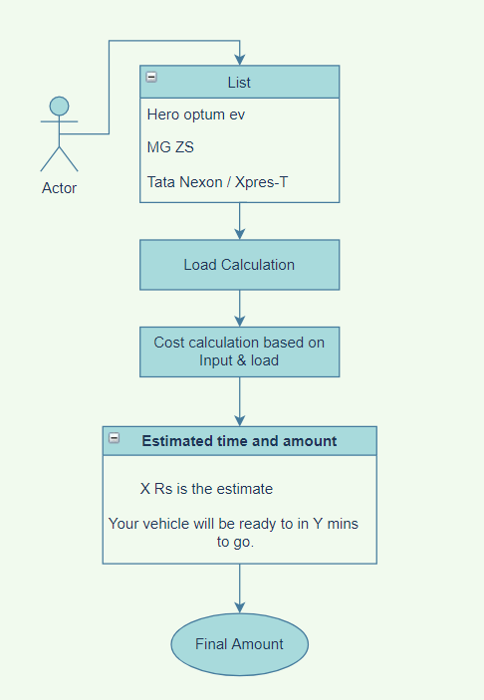

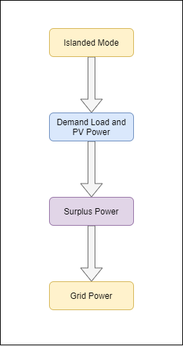



 

# Test Plan

## High Level Test Plan

|  |
| --- |
|  |
| **Test ID** | **Description** | **Exp I/P** | **Exp O/P** | **Actual Out** | **Type Of Test** |
| H_01 | Grid Mode(PV_Power, Load_Demand,ProfitGrid) | (15000,10000,100) | 45 | 45 | Scenario Based |
| H_02 | Islanded Mode(PV_Power, Load_Demand,ProfitGrid) | (18000,12000,100) | 18 | 18 | Scenario Based |
| H_03 | ADD PORT AVAILABILITY | 0/1 | PASS | PASS |  |



## Low Level Test Plan

|  |
| --- |
|  |
| **Test ID** | **Description** | **Exp IN** | **Exp OUT** | **Actual Out** | **Type Of Test** |
| L_01 | Power Calculation (V,I) | (1200,100) | 120000 | 12000 | Scenario Based |
| L_02 | OWNER LogIn | ID, Password | PASS | PASS |  |
| L_03 | CONSUMER INTERFACE | Add amount | PASS | PASS |  |





# Program Outputs

[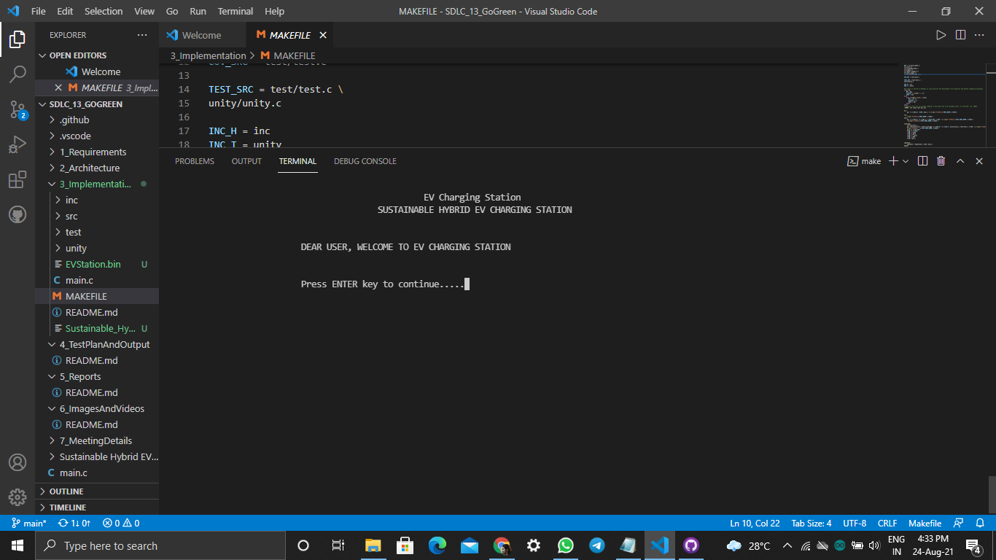](https://user-images.githubusercontent.com/86190226/130607582-563d8930-ad5d-4b39-b56b-d67af0908abf.png)

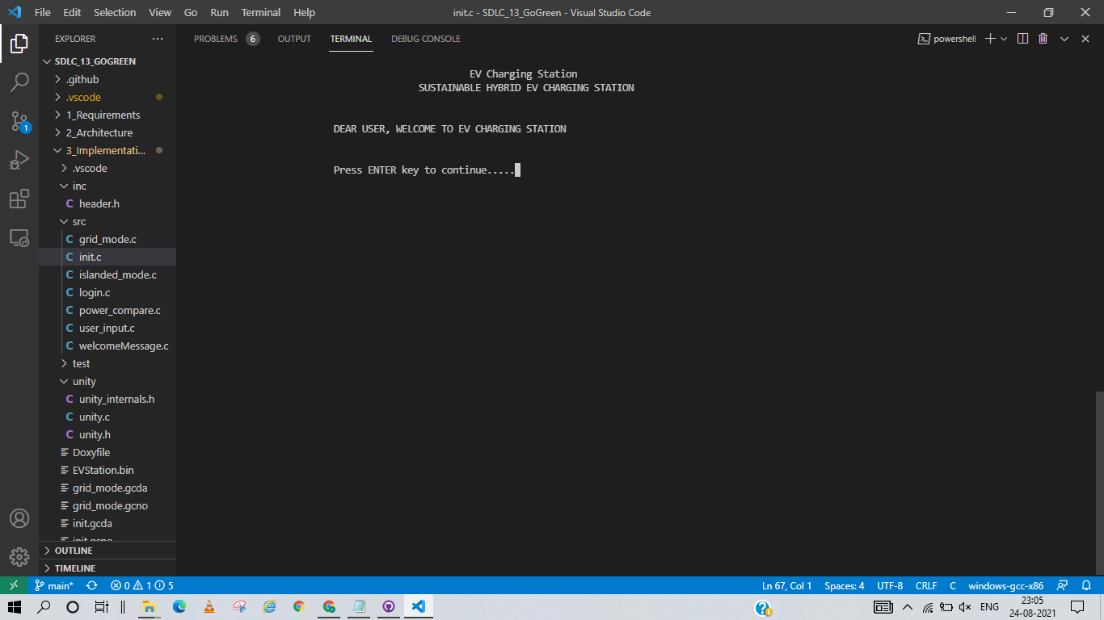

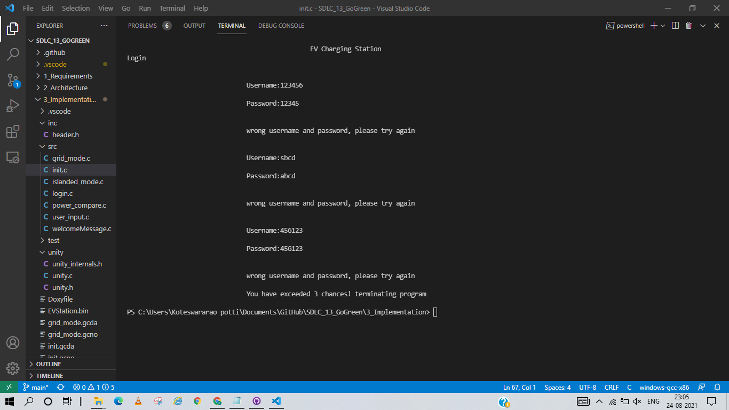

[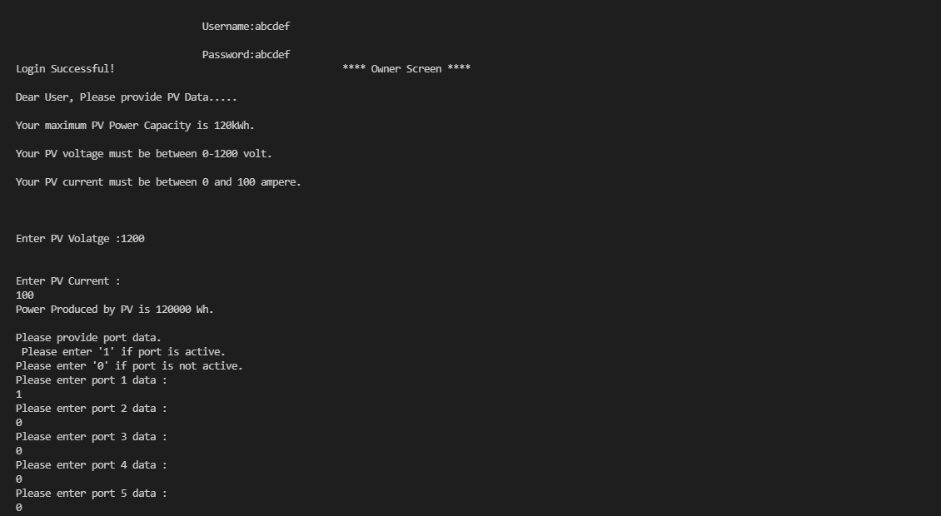](https://user-images.githubusercontent.com/86190226/130607601-016b1957-d607-467e-b043-cc46294aea12.png)

[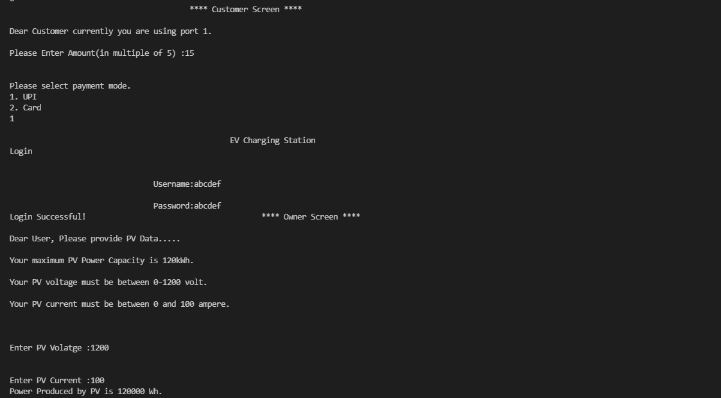](https://user-images.githubusercontent.com/86190226/130607622-7025ac2e-af29-43ab-8972-559b2f10c523.png)

[](https://user-images.githubusercontent.com/86190226/130607639-b7b0fc8e-58c2-41b4-a3e4-d9702f821152.png)

[](https://user-images.githubusercontent.com/86190226/130607660-dcf9ceed-61af-41c9-abf6-5ddc16502515.png)

[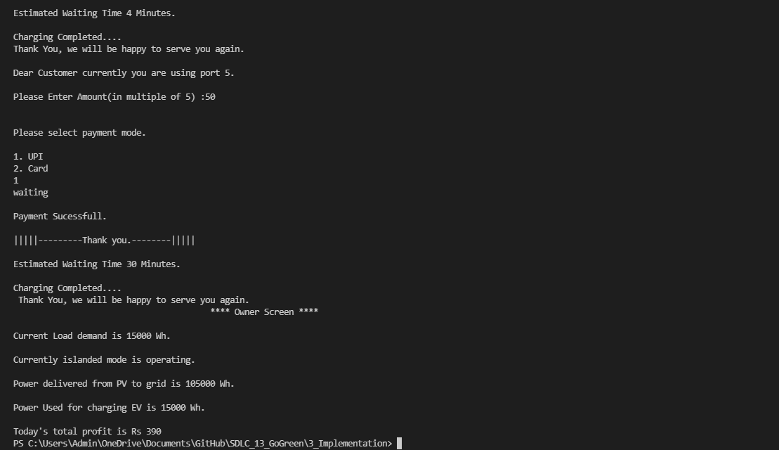](https://user-images.githubusercontent.com/86190226/130607674-984d6e19-561a-4806-aa89-b56af9234334.png)

# Contributions

| **PS** | **Name** | **Features** |  |  |  |
| --- | --- | --- | --- | --- | --- |
| 99005853 | Potukuchi Nagalakshmi Kiranmayee | Makefile and Standup Meeting Details |  |  |  |
| 99005766 | Rohan Tehalyani | Total Earnings, Profit and Cost Function at each port |  |  |  |
| 99005830 | Battula Vineel | Power produced from PV and number of EVs charged |  |  |  |
| 99005835 | Alavelli IndraKumar | Amount of Power obtained from PV Grid and Total Price Calculation |  |  |  |
| 99005836 | Srinivasula Anirudh | Self-Checkout Application for User |  |  |  |
| 99005787 | Abhidha Rajesh Choudhari | User Input for PV Voltage, Current. Estimated waiting time and cost of each EV when Port is active |  |  |  |
| 99005799 | Potti Koteswararao | Power Calculation of PV. EV Charging Station Ports Status. Total time to charge when ports are active |  |  |  |
| 99005798 | Singaraju Amulya | Welcome Message with User ID and Password to login to user (Owner) interface |  |  |  |
| 99005848 | Telagareddy Gangadhar | Calculation of surplus power and net-metering of solar power |  |  |  |
| 99005767 | Deepak Kumar Choudhary | Automatic Power Vending at Ports, Load Demand and its calculation, Power Comparision Function (Islanded Mode and Grid Mode) |  |  |  |

